Rising Pressures, Fading Discipline: A Review of Australia’s Fiscal Sustainability
Australia’s fiscal challenges are getting harder. Over two decades, the overall budget position – state and federal – has slipped into sustained deficit. Debt is higher after two global shocks, and governments have struggled to rebuild fiscal buffers for the next one. There is no imminent debt crisis, but with renewed pressures ahead – like an ageing population and slow productivity growth – Australia's fiscal options are narrowing. The nation’s capacity to weather future shocks, and fairly share burdens across generations, is at risk.
Much of this has occurred without conscious intent. Partly because spending patterns are shaped by rules of thumb and ingrained fiscal habits. And partly because fiscal policy is, increasingly, a collective exercise – state and territory budgets matter as much as the federal Budget for the general government deficit. A first step in navigating Australia’s fiscal challenges is to better understand the drivers of the overall national fiscal position and the stark trade-offs that lie ahead.
Public debate around fiscal policy has underplayed these risks by not taking a consolidated view of government accounts. On a consolidated basis, Australian governments have been running a combined deficit in the fiscal balance every year since the Global Financial Crisis in 2008.
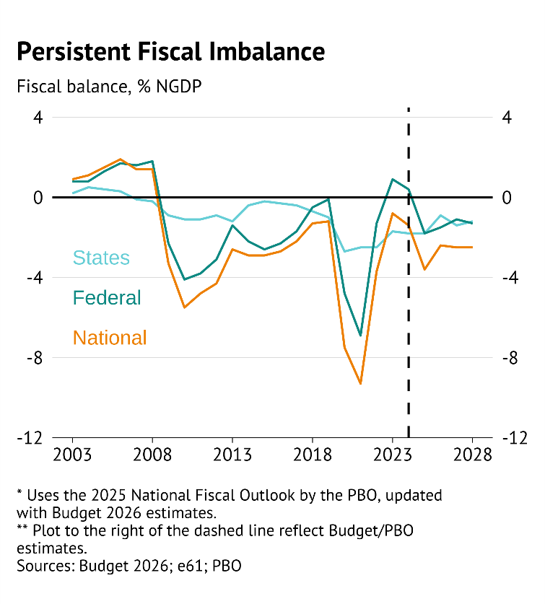
These persistent consolidated deficits highlight the importance of including states, territories and local governments in the discussion around fiscal sustainability. Borrowing by non-federal levels of government has a significant, and growing, effect on fiscal imbalance in Australia. Rising state deficits pose additional challenges to fiscal sustainability as state deficits are arguably harder to reduce. On the spending side, expenditures are tied to the provision of services that are more exposed to the ageing of the population (through the provision of services such as healthcare). While on the revenue side the ability of the states to raise additional revenue is limited by the inefficient taxes available to them.
This leads to fiscal fragility. Borrowing has increased – led by states and territories – at a time when export prices are near record highs, and the labour market remains tight. In the event of a future economic slowdown or crisis, there will be a need for more spending, while revenue will fall. This would see the fiscal position deteriorate quickly into higher deficits and more borrowing.
Such borrowing could be justified if it translated into investments that lowered future costs or supported future economic growth. However, Australia’s consolidated gross debt position has deteriorated over this time – from the 4th lowest among 42 countries in 2007 to the 18th lowest by 2023. This relative slippage has occurred steadily over the last decade, with gradual and permanent increases in government spending creating a classic ‘boiling frog’ situation for the fiscal position – where complacency about slowly increasing debt leads to bigger challenges down the line.
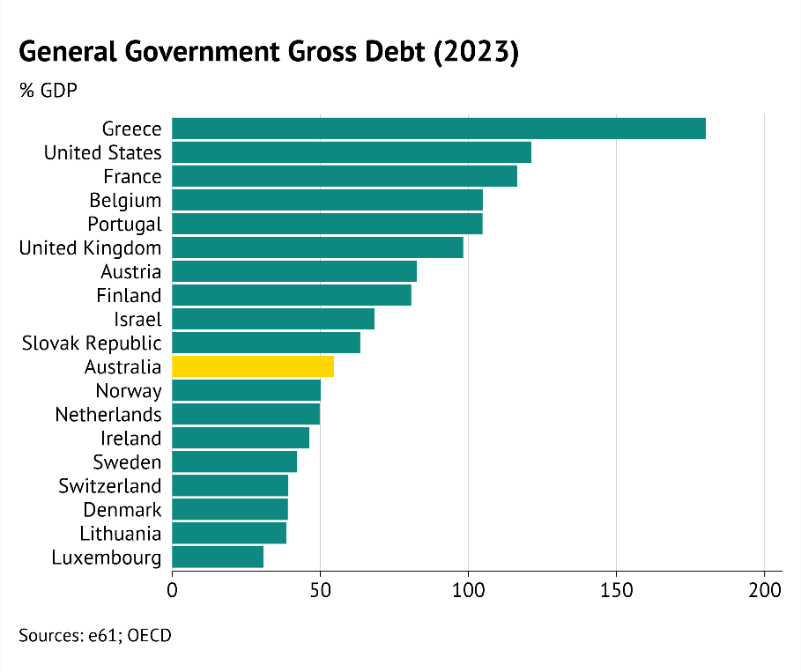
High government debt has mainly been the result of high government spending. Examining the drivers and policy mechanisms behind these spending patterns, we find:
- Ageing pressures: Although an ageing population has been the key driver of rising expenditure over the last decade, its impact has been exacerbated by a gradual loosening in fiscal discipline over the past 25 years.
- Weak productivity growth: Slowing productivity growth has lowered government revenue while spending has failed to adjust to this new reality. Government expenditure has continued to follow previous GDP trends, suggesting that entrenched fiscal habits have contributed to a growing government footprint in the economy.
- Fiscal restraint in some areas: Governments have shown relative restraint over the past 25 years in large areas of government expenditure – namely health and cash transfers. Policy choices regarding hospital funding, means testing, and the indexation of payments have kept a lid on these fiscal costs.
- Expansion elsewhere: In contrast, expenditure on education per student and in-kind transfers have increased significantly. The lack of cost control in both areas has been a policy choice that has put additional pressure on government finances.
Persistently weak productivity growth and population ageing are set to continue to drive up government expenditure as a share of national income unless something changes. There are three key drivers of this:
- Maintaining support for older Australians: A growing number of older Australians will lead to greater demand for healthcare, and a reduction in labour force participation. This ‘demographic penalty’ needs to be funded from a shrinking base of working age people.
- ‘Sticky’ spending patterns: An unwillingness to moderate spending growth in areas that should be providing a ‘demographic dividend’, such as in education.
- Increasing universalism of government spending: An expansion of broad-based, in-kind services and supports, including to middle- and high-income households, gradually shifting away from a focus on income support to alleviate poverty.
These budget difficulties reflect both political and institutional constraints. It is politically difficult to cut overall funding in an area like education, and it is politically expedient to provide income support and services to as broad a voting coalition as possible. They are also exacerbated by the way the budget process works – with implicit fiscal rules and easy to communicate policies often used as a crutch for decision-making by departments and ministers.
The result is a fiscal system that is inconsistent and inflexible. Addressing this requires a much stronger focus on how effectively decisions allocate scarce resources across competing priorities.

Governments are spending unsustainably
Rising consolidated expenditure is a key driver of the increase in government debt. As a share of GDP, expenditure has increased from 34.7 per cent in the early 2000s to 38.2 per cent in 2024 (around 3.5 percentage points).
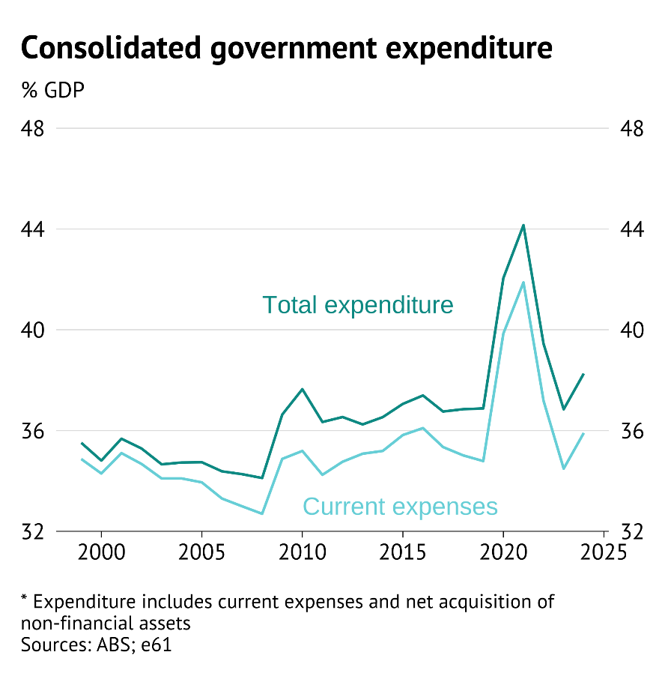
Understanding the increase in government spending as a share of GDP requires having a benchmark for how spending should evolve. Due to factors that boost national income (such as productivity growth or rising export prices), a government that simply provided the same services through time would see spending decline as a share of GDP. This would point to a benchmark that compares the real services provided over time.
However, governments may also expand programs to share the benefits of economic growth. The idea here is that Australian’s are willing to pay for government services and redistribution through taxes, and demand for these services will rise in line with growth in income. This suggests a benchmark that government spending as a share of GDP should remain stable over time.
Using a benchmark where spending is expected to evolve along with GDP, population ageing largely explains the rise in spending particularly since 2013. An older population demands more labour-intensive services such as health, aged care, and disability support, while slowing labour force growth constrains government capacity to raise revenue. An increase in the number of people over retirement age, due to the size of the Baby Boomer cohort, has led to greater spending on health and social protection, such as the Age Pension.
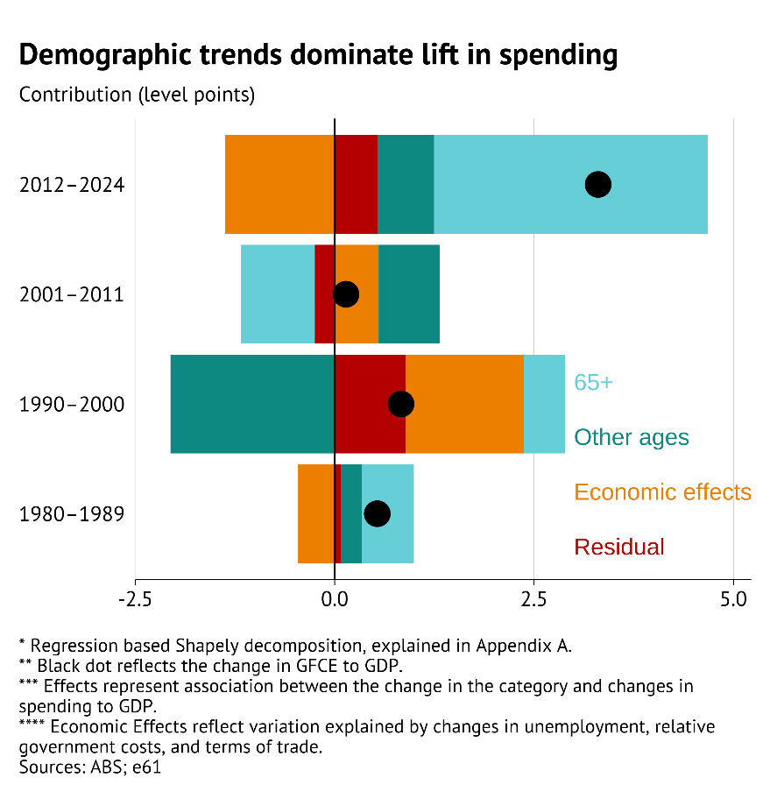
However, there are two significant complications to the narrative that government spending is entirely driven by societal ageing.
First, between 1990 and 2011, favourable demographic change and economic conditions – such as an increase in the working age population and growing export prices during the 2000s – masked an underlying increase in government expenditure from rising costs, higher export prices, and discretionary policy changes. Policymakers effectively spent the prior economic dividend of the ‘mining boom,’ and baked that into budgets as ‘forever’ costs, setting the stage for today’s fiscal challenge.
Second, the composition of the rise in government spending reflects fiscal choices. Relative to what would be expected given population ageing, there has been restraint in age-linked cash programs, such as the Age Pension (due to means testing of benefits and compulsory superannuation), and health spending (due to efficiencies and private insurance). In contrast, policymakers have chosen to increase spending on in-kind services and education, often without a clear link to value-for-money outcomes.

Understanding what government spends on
Like someone working out how to pay down their credit card bill, decision makers need to understand what the government spends money on before they can determine how to save. A starting point is to compare current spending to a benchmark based on historical spending. This identifies areas where recent governments have increased spending, and can be used to project out future spending pressures associated with current programs.
Health spending has evolved broadly in line with ageing pressures, rising from 5.6 per cent in 1999 to over 7.6 per cent of GDP in 2024. This is the result of government reforms through the late 2000s and early 2010s, with lower long-term pharmaceutical prices following Pharmaceutical Benefits Scheme (PBS) reform, below-CPI Medicare indexation, and improvements in technical efficiency as a result of activity-based funding. Apart from indexation, these reforms had an initial cost which boosted health spending but have placed the sector on a more sustainable long-term path.
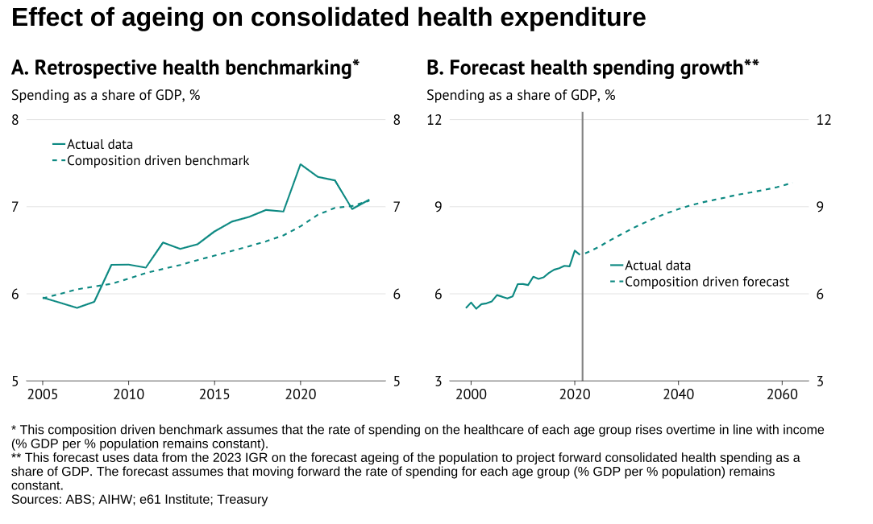
Age Pension expenditure has been restrained by policy decisions such as tighter means testing and the introduction of compulsory superannuation. Spending on age-related social support has remained around its 25-year average of 4.5 per cent of GDP, even as the share of the population over the age of 65 has increased from 12 per cent to 17 per cent between 1999 and 2024.
However, instead of banking these savings to restore fiscal balance, governments have redirected the funds to other areas. Social protection spending has shifted away from cash transfers – such as unemployment benefits and family assistance – toward in-kind supports – such as child care and the National Disability Insurance Scheme (NDIS). Spending on these in-kind supports is expanding due to relatively universal eligibility. Going forward, it will be difficult to control the cost of in-kind supports. These services are labour intensive and hands-on. As demand rises, so too will wage costs.
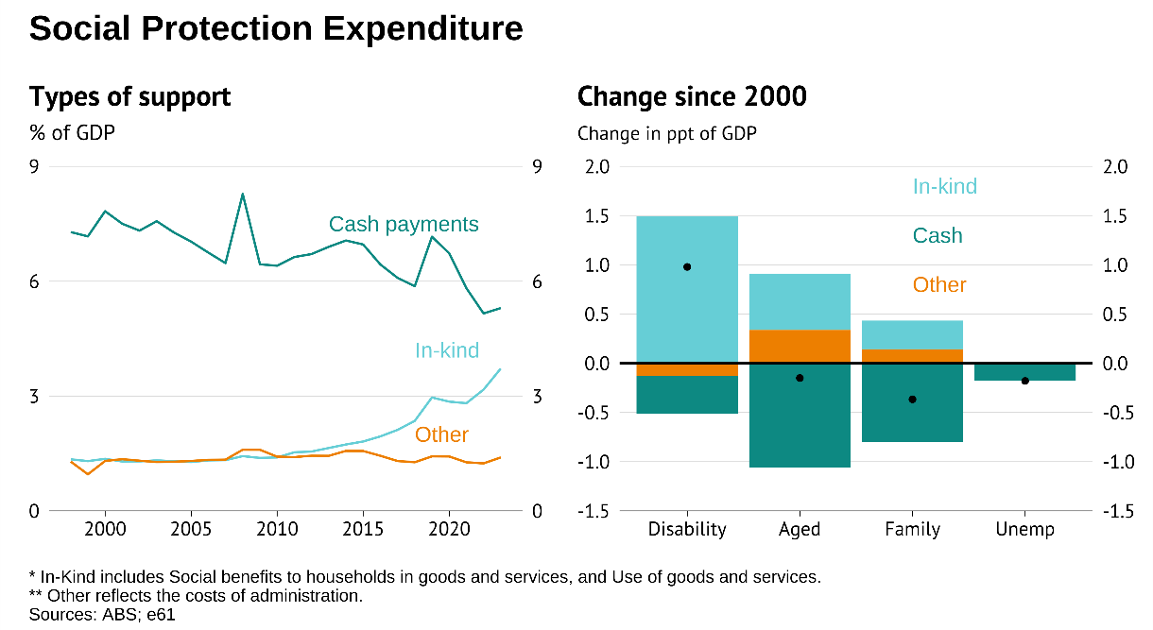
Meanwhile, education spending has remained at 5 per cent of GDP, even as the share of the population that is of school-age has declined. Between 1999 and 2014, per-student spending increased by around half a percentage point of GDP above what demographic trends predict. This largely reflects underlying funding mechanisms in the education sector in the ‘Gonski’ school reform era that have tended to boost funding per student, especially for private schools with lower levels of public funding.
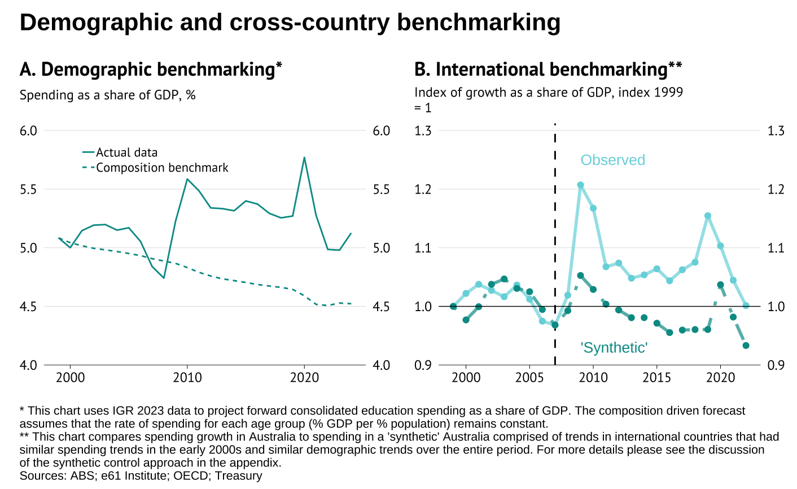
Taken together, the problem is not an absence of control where the spending pressures from ageing are obvious, but rather a lack of fiscal discipline in areas where ageing is not the key driver. The result has been a surge in spending per person on in-kind social services and education.
Looking ahead, there are two additional areas likely to place upward pressure on government spending: defence and the economic activity function (such as business bailouts and wage subsides). Rising geopolitical instability may necessitate a larger investment in defence infrastructure and increased government involvement in sectors deemed to be of national interest. Spending an additional 1-2 per cent of GDP on these areas would place further pressure on the general government’s fiscal position.
These trends raise important questions about value for money. Health outcomes have improved only modestly despite large real spending increases; social protection is less targeted and less effective at reducing poverty; student outcomes have declined despite rising investment; and defence procurement is already struggling with delays and cost overruns.

Conclusion
These spending pressures are occurring in an environment where it is becoming more difficult for the government to raise additional revenue. Even if spending was maintained at its current share of GDP, the federal government will still need to increase average income tax rates from 24.3 per cent to 27.7 per cent over the next 10 years to achieve budget balance
On this current path, it is unlikely that government debt will naturally decline. Slower productivity growth is providing less revenue to finance new or expanded services, while spending continues to rise as the population ages. This ageing is unavoidable, but the fiscal cost depends on policy decisions that are made now.
This makes an increase in government debt likely. Larger government debt implies that future generations must pay for some current government expenditure, and all levels of government will be less able to support Australians if faced with a large external shock
Unsustainable spending growth is a product of fiscal habits and rules established during good times that have led to less spending discipline now. While gaps in the tax system make the cost of raising revenue higher than it needs to be to fund current spending. This unsustainability plays out three key economic costs – fragility, inequity, and inefficiency.
Fragility
Current spending patterns make the Australian economy fragile in the face of unexpected events. On the other hand, resilient fiscal settings are able to absorb shocks and structural changes without entrenching permanent spending increases. Reform directions that could strengthen resilience include: independent assessment and analysis of fiscal settings; adopting longer-term budget horizons; better integration of federal-state service provision; and introducing explicit soft fiscal rules that are credible but can adapt to demographic and macroeconomic change.
Inequity
Fiscal choices should distribute risks and opportunities fairly across generations and income groups. The shift toward in-kind and universal supports has improved access to services but reduced the system’s progressivity and created new fiscal pressures. Assessing how this shift has changed the distribution of who pays – and ensuring younger cohorts are not over-burdened by age-related spending – is fundamental to sustaining intergenerational fairness.
Inefficiency
Habit based fiscal choices don’t guarantee value for money and the efficiency of both spending and tax financing. Spending reviews should focus on outcomes not just inputs, and agencies should be provided with new tools to incorporate a whole of government lens to their advice. Strengthening independent fiscal advice and consistently assessing the benefit of projects against the cost of revenue raising will generate a fiscal environment that rewards good choices.
What does this mean practically? Absent reform to the tax system spending restraint will be needed to avoid burdening future generations with a fragile, inequitable and inefficient Australian economy.
Decisions about where government should show spending restraint depends on a well-informed community debate based on trade-offs. A stronger emphasis on the per-user cost of programs, or curtailing cost pressures through greater means testing of in-kind transfers, are potential directions – but when informed the community may decide support cuts in certain areas to maintain more generous support in others.
Australia's fiscal institutions have served the nation well but, as low productivity growth and an ageing population make the fiscal arithmetic more difficult, the way these institutions work may need some refinement. Future work by e61 will explore these issues.

These real services have to be measured relative to the cost of providing the service. Due to the labour intensive nature of government services, the cost of provision tends to rise more quickly than the cost of private consumption. Although historically this still leads to a benchmark that declines as a share of GDP, in a world of slow productivity growth and increased public provision of in-kind services, this may not continue to be the case.

